Task1:

importjava.util.*;
import java.util.function.Function; importjava.util.stream.Collectors;

classMain{
publicstaticvoidmain(String[]args){

Scannersc=newScanner(System.in);

intn=sc.nextInt();

List<Integer>salaries=newArrayList<>();

for(inti=0;i<n;i++){
salaries.add(sc.nextInt());
}

Function<Integer,Integer>increaseSalary=salary->salary+ (salary*10/100);

List<Integer>updatedSalaries=salaries.stream()

.map(increaseSalary)
.collect(Collectors.toList());

for(intsalary:updatedSalaries){ System.out.print(salary+"");
}
}
}

Output:

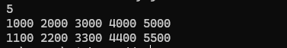

Task2
importjava.util.*;
importjava.util.stream.Collectors;

classMain{

static class Reading { StringsensorId; doubletemperature;

Reading(StringsensorId,doubletemperature){ this.sensorId = sensorId;
this.temperature=temperature;
}
}

publicstaticvoidmain(String[]args){

Scannersc=newScanner(System.in);

intn=sc.nextInt();

List<Reading>readings=newArrayList<>();

for(inti=0;i<n;i++){
StringsensorId=sc.next();
doubletemperature=sc.nextDouble();

readings.add(newReading(sensorId,temperature));
}

Map<String,Double>result=readings.stream()

//1.Filtertemperaturegreaterthan50
.filter(r->r.temperature>50)

//2C3.GroupbysensorIDandcalculateaverage
.collect(Collectors.groupingBy( r->r.sensorId,
Collectors.averagingDouble(r->r.temperature)
));

//4.Sortbyaveragetemperatureindescendingorder result.entrySet().stream()

.sorted(Map.Entry.<String,
Double>comparingByValue().reversed())
.forEach(entry->
System.out.println(entry.getKey() + "" + entry.getValue())
);
}
}

Output:
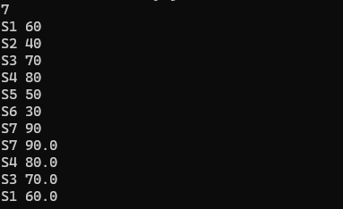

Task3:
importjava.util.*;

classMain{
publicstaticvoidmain(String[]args){

Scannersc=newScanner(System.in);

intn=sc.nextInt();

int[]arr=newint[n];

for(inti=0;i<n;i++){ arr[i]=sc.nextInt();
}

intcurrentSum=arr[0]; intmaxSum=arr[0];

for(inti=1;i<n;i++){

currentSum=Math.max(arr[i],currentSum+arr[i]);

maxSum=Math.max(maxSum,currentSum);
}

System.out.println(maxSum);
}
}

Output:

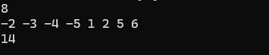

Task4:
importjava.util.*; class Main {
// Create LPS (Longest Prefix Suffix) array staticint[]createLPS(Stringpattern){

int[]lps=newint[pattern.length()];

intlen=0; inti=1;

while(i<pattern.length()){

if(pattern.charAt(i)==pattern.charAt(len)){ len++;
lps[i]=len; i++;
}else{
if(len!=0){
len=lps[len-1];
}else{
lps[i]=0; i++;

}
}
}

returnlps;
}

//KMPpatternsearching
staticvoidsearch(Stringtext,Stringpattern){

int[]lps=createLPS(pattern);

inti=0; intj=0;

while(i<text.length()){
if(text.charAt(i)==pattern.charAt(j)){ i++;
j++;
}

if(j==pattern.length()){ System.out.print((i-j)+"");

j=lps[j-1];
}elseif(i<text.length()
CCtext.charAt(i)!=pattern.charAt(j)){

if(j!=0){
j=lps[j-1];
}else{ i++;
}
}
}
}

publicstaticvoidmain(String[]args){

Scannersc=newScanner(System.in);

Stringtext=sc.nextLine(); String pattern = sc.nextLine();

search(text,pattern);
}
}

Output:

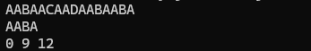

Task5:
importjava.util.*; classBankAccount{
intbalance=0;
voiddeposit(intamount){
balance=balance+amount;
}
voidwithdraw(intamount){ balance=balance-amount;
}

intgetBalance(){ returnbalance;
}
}

classMain{
publicstaticvoidmain(String[]args){

Scannersc=newScanner(System.in);

intn=sc.nextInt(); sc.nextLine();

BankAccountaccount=newBankAccount();

for(inti=0;i<n;i++){

Stringoperation=sc.nextLine();

String[]parts=operation.split("");

Stringtype=parts[0];
intamount=Integer.parseInt(parts[1]);

if(type.equals("Deposit")){ account.deposit(amount);
}
elseif(type.equals("Withdraw")){ account.withdraw(amount);
}
}

System.out.println(account.getBalance());
}
}

Output:
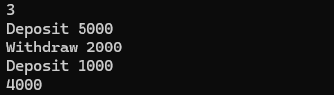

Task6:
importjava.util.*;

class Driver { Stringname;

Driver(Stringname){ this.name=name;
}
}

class Rider { Stringname;

Rider(Stringname){ this.name=name;
}
}

class Vehicle { Stringnumber;

Vehicle(Stringnumber){

this.number=number;
}
}

//Parentclass
abstractclassTrip{ doubledistance;

Trip(doubledistance){
this.distance=distance;
}

abstractdoublecalculateFare();
}

//Bikeride
classBikeextendsTrip{

Bike(doubledistance){ super(distance);
}

doublecalculateFare(){

returndistance*5;
}
}

//Autoride
classAutoextendsTrip{

Auto(doubledistance){ super(distance);
}

doublecalculateFare(){ returndistance*12;
}
}

//Cabride
classCabextendsTrip{

Cab(doubledistance){ super(distance);
}

doublecalculateFare(){ returndistance*12;
}
}

classMain{
publicstaticvoidmain(String[]args){

Scannersc=newScanner(System.in);

intn=sc.nextInt();

for(inti=0;i<n;i++){

Stringtype=sc.next();
doubledistance=sc.nextDouble();

try{

if(distance<=0){
thrownewIllegalArgumentException("Invaliddistance");
}

Triptrip;

if(type.equals("Bike")){trip=newBike(distance);
}
elseif(type.equals("Auto")){ trip=newAuto(distance);
}
elseif(type.equals("Cab")){ trip=newCab(distance);
}
else{
thrownewIllegalArgumentException("Invalidridetype");
}

System.out.println((int)trip.calculateFare());

}catch(IllegalArgumentExceptione){ System.out.println("Invalidbooking");
}
}
}
}

Output:

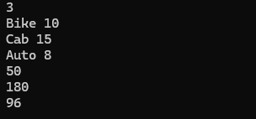

Task7:
importjava.util.*; class Main {
publicstaticvoidmain(String[]args) Scannersc=newScanner(System.in);

intn=sc.nextInt();

Map<String,Integer>frequency=newLinkedHashMap<>();

for(inti=0;i<n;i++){

Stringhashtag=sc.next();

frequency.put(hashtag,
frequency.getOrDefault(hashtag,0)+1);
}

for (Map.Entry<String, Integer> entry : frequency.entrySet()) { System.out.println(entry.getKey()+""+entry.getValue());
}
}
}

Output:
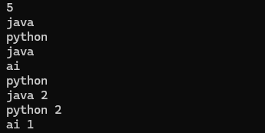

Task8:
importjava.util.*;

classMain{
publicstaticvoidmain(String[]args){

Scannersc=newScanner(System.in);

intn=sc.nextInt(); intm=sc.nextInt();

//Creategraph
List<List<Integer>>graph=newArrayList<>();

for(inti=0;i<=n;i++){
graph.add(newArrayList<>());
}

//Readroads
for(inti=0;i<m;i++){

intu=sc.nextInt(); intv=sc.nextInt();

//Undirectedgraph graph.get(u).add(v);
graph.get(v).add(u);
}

intsource=sc.nextInt();
intdestination=sc.nextInt();

//BFS
boolean[]visited=newboolean[n+1];
Queue<Integer>queue=newLinkedList<>();

queue.add(source);
visited[source]=true;

while(!queue.isEmpty()){

intcurrent= queue.poll();

if(current==destination){ System.out.println("YES"); return;

}

for(intnext:graph.get(current)){

if(!visited[next]){
visited[next]=true; queue.add(next);
}
}
}

System.out.println("NO");
}
}

Output:
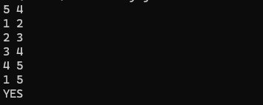

TaskG:
importjava.util.*;

classCalculator{

intadd(inta,intb){ returna+b;
}

intdivide(inta,intb){ if(b==0){
thrownewArithmeticException("Cannotdividebyzero");
}

returna/b;
}
}

classMain{
publicstaticvoidmain(String[]args){

Scannersc=newScanner(System.in);

inta=sc.nextInt();
String operator = sc.next(); intb=sc.nextInt();

Calculatorcalculator=newCalculator();

try{

intresult;

if(operator.equals("+")){ result=calculator.add(a,b);

//Unittest
assertresult==30;

}elseif(operator.equals("/")){ result = calculator.divide(a, b);

//Unittest
assertresult==a/b;

}else{

System.out.println("Invalidoperator"); return;
}

System.out.println("TestPassed");

}catch(AssertionErrore){ System.out.println("Test Failed");

}catch(ArithmeticExceptione){ System.out.println("Test Failed");
}
}
}

Output:

Task10:
importjava.util.*;

classLoginSystem{

//Validlogindetails
booleanlogin(Stringusername,Stringpassword){

//Boundaryvaluevalidation
if(username.length()< 3||username.length() >20){ returnfalse;
}

if (password.length() < 6 || password.length() > 20) { returnfalse;
}

//Checkusernameandpassword
returnusername.equals("admin")CC password.equals("admin123");
}
}

classMain{
publicstaticvoidmain(String[]args){

Scannersc=newScanner(System.in);

intn=sc.nextInt();

LoginSystemsystem=newLoginSystem();

for(inti=0;i<n;i++){

Stringusername=sc.next(); Stringpassword=sc.next();

try{

booleanresult=system.login(username,password);

if(result){
System.out.println("SUCCESS");
}else{
System.out.println("FAILURE");
}

}catch(Exceptione){ System.out.println("FAILURE");
}
}
}
}

Output:
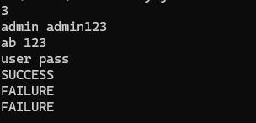

UseCase1:
importjava.util.Scanner;
publicclassVehicleEntryManagement{ publicstaticvoidmain(String[]args){
Scannersc=newScanner(System.in); intlevels=3;
intslots=5;
boolean[][]occupied=newboolean[levels][slots]; System.out.println("=====VehicleEntryManagement
=====");
System.out.print("EnterVehicleNumber:"); StringvehicleNo=sc.nextLine();
intassignedLevel=-1;
intassignedSlot=-1;

//Findnearestavailableparkingslot for(inti=0;i<levels;i++){
for(intj=0;j<slots;j++){ if(!occupied[i][j]){
assignedLevel=i+1; assignedSlot=j+1; occupied[i][j]=true; break;

}
}
if(assignedLevel!=-1){ break;
}
}

//Displayresult
if(assignedLevel==-1){
System.out.println("\nParkingFull!Noslotavailable.");
}else{
System.out.println("\n-----VehicleDetails ");
System.out.println("VehicleNumber:"+vehicleNo); System.out.println("ParkingLevel:"+assignedLevel); System.out.println("ParkingSlot:"+assignedSlot);
System.out.println("Status :ParkingAllocated Successfully");
}
sc.close();
}
}

Output:
